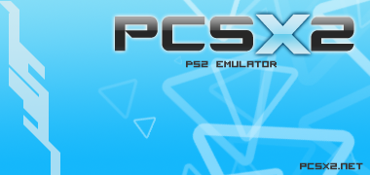

PCSX2 is a PlayStation 2 emulator for Windows and Linux, started by the same team that brought you PCSX (a Sony PlayStation 1 emulator).
The PCSX2 project attempts to allow PS2 code to be executed on your computer, thus meaning you can put a PS2 DVD or CD into your computers drive, and boot it up!

Overview
The project has been running for more than five years now, and since its’ initial release has grown in compatibility. From initially just being able to run a few public domain demos, it's current state enables many games to boot and actually go in game, such as the 'famous' Final Fantasy X, Devil May Cry 3 and God of War. You can always visit the PCSX2 homepage to check the latest compatibility status of games with more than 2000 titles tested.

Following our new release scheme as described here, v0.9.7 is a beta release. This means that some things are not yet complete (see list below). Still, this is an official release, fully tested and supported on our forum.

What’s new in 0.9.7?
- New GUI based on wxWidgets working on a separate thread
- microVU, an all new VU0/VU1 recompiler
- VIF rewritten
- IPU improvements, many more videos now play perfectly
- Stable full screen operation with GSdx
- Many new emulation options, complete with tooltips
- New MTGS, much more efficient and compatible
- New BIOS skipping method, more compatible and correct
- Turbo/Slow motion settings for the frame limiter
- On the fly changing of settings and plugins
- Saving/Loading states does not pause gameplay
- Built in ISO reader with a recently used ISO list
- Suspend / Resume emulation safely and fast
- Simplified plugin configuration dialog, with more options
- Full DVD9 game support (for example God of War, Xenosaga, Gran Turismo 4 etc)
- First time configuration wizard
- Settings stored in your User documents folder by default to prevent Vista / Windows 7 permission issues
- Game database detecting the game you run and auto applies special fixes if needed
- Many important plugin updates, GSdx has many bugs and memory leaks fixed, SPU2-X makes dozens of games boot which never did before
- And a huge amount of improvements and bug fixes which we don’t remember anymore

Known issues of beta release 0.9.7

- Multitap not implemented yet
- Command line support not implemented yet
- GSdx DX9 Hardware mode lacks various features
- Translation system not implemented yet
- Game database not complete
- Patches browser not implemented yet

Configuration

A very detailed guide is available on the PCSX2 homepage which is already translated in several languages! You can consult it here

Status

PCSX2 has come a long way since its’ starting point back at 2002. Current features include:

- Separate recompilers for Emotion Engine (EE) , Vector Unit 0 (VU0) and Vector Unit 1 (VU1).
- Dual core support, with the Graphics Synthesizer (GS) running on a second thread.
- Usage of MMX,SSE1,SSE2,SSSE3 and SSE4 extensions
- Proper SPU2 emulation featuring Auto DMA and Time Scaling
- Full gamepad support featuring Dual Shock 2,analog controls and even supporting analog movement over keyboard (using some external plugins)
- Patch system for creating cheats and for workarounds on games

Sections that still need work:

- Dev9 functions, such as HDD and Ethernet (partially implemented) support
- Firewire emulation (quite low on the list though)
- USB emulation (very partially implemented)
- Image Processing Unit (IPU) emulation which is responsible for the FMV playback. It has been implemented but it is buggy and slow
- MIPS cache needs to be properly implemented (barely works at this time)

How can you help

As most of you are aware, the PCSX2 team is working on this project at the expense of their free time and provide it without charging the program’s use. If you want to show your appreciation to these people and motivate them, you can donate any amount of money you feel is right to the team’s paypal account found in the official site. These funds will be used so the team members can get more modern and new hardware in order to test and debug more efficiently and even implement new features (just like dual core support for example).

If you are a programmer and you are interested in helping the PCSX2 team by making additions or corrections to the code, you are free to browse through the public Google Code repository here after taking into account PCSX2 is under the GNU General Public Licence (GPL) v3

The Coding Team

Below you can see 3 tables, showing the current team members who are actively coding at the present time, the current team members who have been inactive for some time and the older team members who for some reason quit along the way, which include the previous project leader Linuzappz to whom we send our best regards ☺

Current active team members:
Nickname | Real Name | Place | Comments
refraction | Alex Brown | England | General Coding: DMA (VIF / GIF), IPU, etc.
arcum42 |  |  | Linux compatibility and porting; code conformity.
cottonvibes |  | USA | FPU and VU recompilers, general coding
drkIIRaziel |  | Greece | Memory management, emulation theory/principals, recompiler design.
gigaherz |  | Spain | Plugin/DMA stuff, SPU2-X, cdvdGigaherz
air | Jake Stine | USA | User interface (wxWidgets), MTGS, counters, general coding, SPU2-X
pseudonym |  | England | EE recompiler (optimizations & bugfixes), GSdx renovations
rama |  | Germany | Resident problem solver; uses random values until they fix something, then figures out why :P

Current inactive team members:
Nickname | Real Name | Place | Comments
florin | Florin Sasu | Romania | Master of HLE. Master of cd code and bios HLE.
Nachnbrenner |  | Germany | patch freak :P
aumatt |  | Australia | a bit of everything mostly handles CDVD cmds
saqib |  | Pakistan | Former project leader, fixing bugs around (FPU, Interpreter, IPU, VUs)
Shadow | George Moralis | Greece | Project founder, master of cpu, master of bugs, general coding…
tmkk |  |  | VUs, recompilers, x86asm
Goldfinger |  | Brazil | MMI, FPU and general stuff
loser |  | Australia | obscure cdvd related stuff
zerofrog |  | USA | Recompilers, ZeroGS, x86-64, linux, optimizations, general fixes and new features

Ex team members:
Nickname | Real Name | Place | Comments
Linuzappz |  | Argentina | Project founder, master of The GS emulation and so many others..
basara |  |  | Recompiler programmer. general coding
[TyRaNiD] |  |  | GS programmer. General coding.
Roor |  |  | General coding

Additional code contributions by:
F|RES, Pofis, Nocomp, _Riff_, fumofumo, Nneeve

The Beta Tester Team

Beta testers are people (slaves/mindless grunts :P) who constantly test new PCSX2 beta builds to report any new bugs, regressions or improvements. While this might sound simple to most, what many people do not know is that testers also debug with the coders, maintain the huge game compatibility list, create dumps and logs for the coders and so much more. As above, active, inactive and ex members are listed alphabetically

Current active members:
Bositman, Falcon4Ever, GeneralPlot, Prafull

Current inactive team members:
Belmont, CKemu, Crushtest, Knuckles, Krakatos, Raziel, RudyX, Parotaku

Ex team members:
Chaoscode, CpUMasteR, EFX , Elly, JegHegy, Razorblade, RPGWizard, Seta San, Snake875

Release date chart

Here’s a little something we made after careful and time consuming searching over archived news about PCSX2 releases! It’s a timeline chart showing the PCSX2 release dates since 0.1. Thanks to gigaherz for creating the chart.

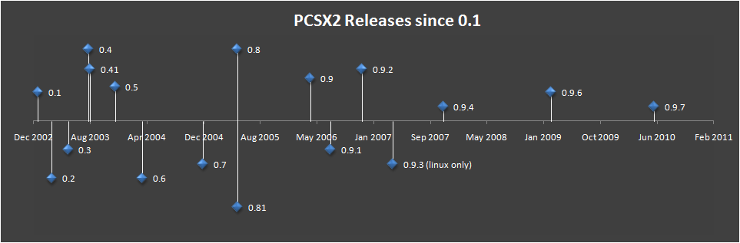

And here are the actual release dates for those of you who are curious:

PCSX2 Version | Date Released
0.026 | 23 March 2002
0.031 | 14 April 2002
0.036 | 17 June 2002
0.038 | 7 July 2002
0.042 | 11 September 2002
0.1 | 20 December 2002
0.2 | 19 February 2003
0.3 | 2 May 2003
0.4 | 31 July 2003
0.41 | 7 August 2003
0.5 | 25 November 2003
0.6 | 24 March 2004
0.7 | 17 December 2004
0.8 | 16 May 2005
0.81 | 17 May 2005
0.9 | 3 April 2006
0.9.1 | 3 July 2006
0.9.2 | 18 November 2006
0.9.3 (Linux only) | 1 April 2007
0.9.4 | 11 November 2007
0.9.6 | 1 March 2009
0.9.7 beta | 29 May 2010

Additional thanks and credits
Duke of NAPALM | For the 3d stars demo. The first demo that worked in pcsx2 :)
Tony Saveski (dreamtime) | For his great ps2tutorials!!
F|res | Author of dolphin, a big thanks from shadow..
Now3d | The guy that helped shadow at his first steps..
Keith | Who believed in us..
Bobbi & Thorgal | For hosting us, for the old page design and so many other things
Sjeep | Help and info
BGnome | Help testing stuff
Dixon | Design of the old pcsx2 page, and the pcsx2.net domain
No-Reccess | Nice guy and great demo coder :)
NSX2 team | For their help with VU ;)
Razorblade | For the old PCSX2 logo & icon.
Snake | He knows what for :P
Ector | Awesome emu :)
Zezu | A good guy. Good luck with your emu :P
Hiryu & Sjeep | For their libcdvd (iso parsing and filesystem driver code)
Sjeep | For the SjDATA filesystem driver
F|res | For the original DECI2 implementation
libmpeg2 | For the mpeg2 decoding routines
Aumatt | For applying fixes to pcsx2
Microsoft | For Visual Studio Express 2008/2010!

and probably to a few more..

Special Shadow's thanks go to...
My friends: Dimitris, James, Thodoris, Thanasis and probably to a few more..and of course to a lady somewhere out there....

Updated for v0.9.7 by bositman.

The PCSX2 Coding and Beta testing team

